

NAME: OBUONG CLAIRE ANYANGO
ADM NO : BSCCS/2024/52885
COURSE : BACHELOR OF SCIENCE IN COMPUTER SCIENCE
UNIT CODE: BIT4138
UNIT NAME: ADVANCED CRYPTOGRAPHY
LECTURER NAME : NYORO MICHAEL
ACADEMIC YEAR: YEAR 3

PROJECT TITLE: Secure File Encryption System
SELECTED TECHNOLOGIES:
Python
VS Code
Python Cryptography Library
OpenSSL
GitHub
GITHUB LINK
https://github.com/claireobuong/advanced-cryptography

Table of Contents
Week 1 4
1.1 Installation and Configuration of Cryptography Development Environment 4
1.2 Reflection 5
Week 2 6
2.1 Implementation of Classical Encryption Algorithms 6
2.2 Reflection 7
Week 3 8
3.1 Implementation of Stream Cipher Systems and Random Sequence Analysis 8
3.2 Reflection 10
Week 4 10
4.1 Advanced Encryption Standard (AES) and Block Cipher Operations 10
4.2 Reflection 11
Week 5 12
5.1 Implementation of RSA Encryption and Key Management 12
5.2 Reflection 13
6. Creative task 14
6.1 Advanced Cryptography Toolkit: Interactive Encryption and Security Analysis System 14
6.2 Summary 16

Table of figures
Figure 1: Confirms successful installation of Python and VS Code, providing the development environment required for implementing and testing cryptographic algorithms. 4
Figure 2: Verifies successful installation of the Python Cryptography library, enabling secure encryption and decryption operations within the project. 4
Figure 3: Confirms proper installation and configuration of OpenSSL, a widely used toolkit for generating cryptographic keys and certificates. 4
Figure 4: Demonstrates successful execution of a local encryption script, validating the functionality of symmetric encryption and decryption operations. 5
Figure 5: Illustrates initialization of the GitHub repository and version control setup, supporting secure code management and project tracking. 5
Figure 6: Demonstrates the implementation of the Caesar Cipher algorithm, where each character is shifted by a user-defined key to produce encrypted output. 6
Figure 7: Illustrates the Vigenère Cipher encryption process, where a keyword is used to generate multiple substitution alphabets, improving security over simple shift ciphers. 6
Figure 8: Confirms the successful encryption and decryption of plaintext, demonstrating that the original message can be accurately recovered using the correct key. 7
Figure 9: Demonstrates the user input interface, allowing dynamic entry of plaintext and encryption keys while validating numerical input for the Caesar Cipher. 7
Figure 10: Presents the testing results obtained using different plaintext messages and encryption keys, verifying the correctness and consistency of the implemented algorithms. 7
Figure 11: Implementation of a pseudorandom sequence generator for stream cipher security analysis. 8
Figure 12: Generated pseudorandom binary sequence used for randomness analysis. 8
Figure 13: Statistical testing results showing frequency, runs, and mean analysis of the generated binary sequence. 9
Figure 14: RC4-style stream cipher simulation demonstrating XOR-based encryption and decryption. 9
Figure 15: Encryption and randomness testing results successfully generated and stored for later analysis. 9
Figure 16: Python implementation of an AES-based encryption script using the Cryptography library. 10
Figure 17: Automatic generation of a symmetric encryption key used for AES operations 10
Figure 18: Encrypted output successfully stored in a file for secure data protection. 11
Figure 19: Successful decryption process demonstrating recovery of the original plaintext using the correct encryption key. 11
Figure 20: AES encryption performance measurement showing the execution time required for the encryption process. 11
Figure 21: Successful generation of RSA public and private key pairs for secure communication. 12
Figure 22: Encryption of plaintext using the RSA public key. 12
Figure 23: Successful decryption of ciphertext using the RSA private key. 12
Figure 24: RSA secure message transmission demonstrating protection of data during communication. 13
Figure 25: RSA encryption and decryption successfully tested and validated through execution time measurement. 13
Figure 26: GUI-based XOR stream cipher demonstrating secure encryption and successful decryption using a shared key. 14
Figure 27: Randomness analyzer generating binary sequences and evaluating frequency distribution. 15
Figure 28: Block cipher simulator implementing block division, substitution, and permutation operations. 15
Figure 29: Avalanche effect demonstration showing how a small plaintext change produces significant cryptographic differences 15
Figure 30: Digital fingerprint generator using SHA-256 hashing for message integrity verification. 16

Week 1

1.1 Installation and Configuration of Cryptography Development Environment
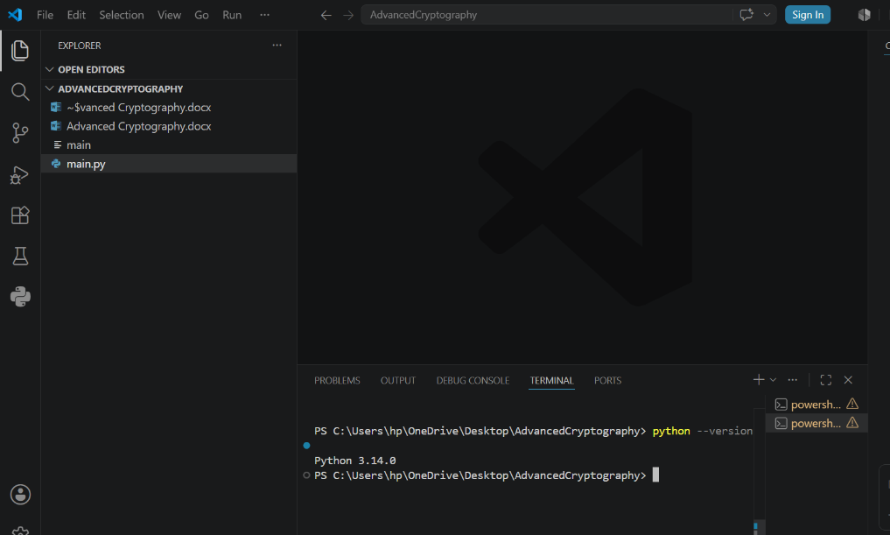
Figure 1: Confirms successful installation of Python and VS Code, providing the development environment required for implementing and testing cryptographic algorithms.

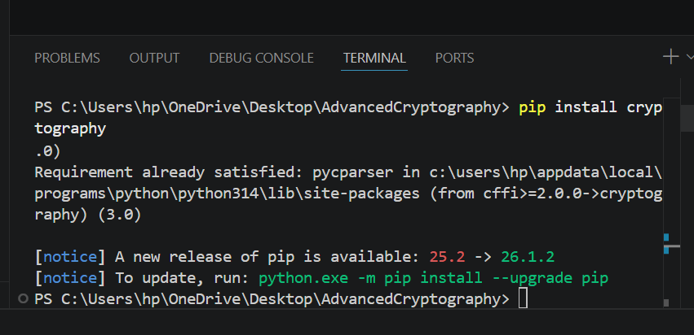
Figure 2: Verifies successful installation of the Python Cryptography library, enabling secure encryption and decryption operations within the project.

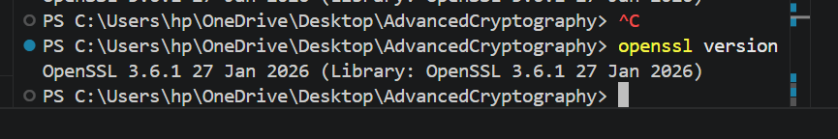
Figure 3: Confirms proper installation and configuration of OpenSSL, a widely used toolkit for generating cryptographic keys and certificates.
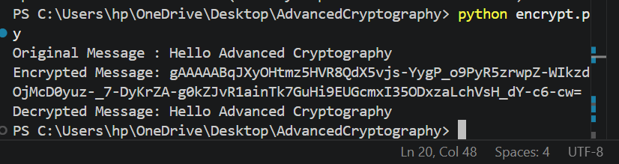
Figure 4: Demonstrates successful execution of a local encryption script, validating the functionality of symmetric encryption and decryption operations.

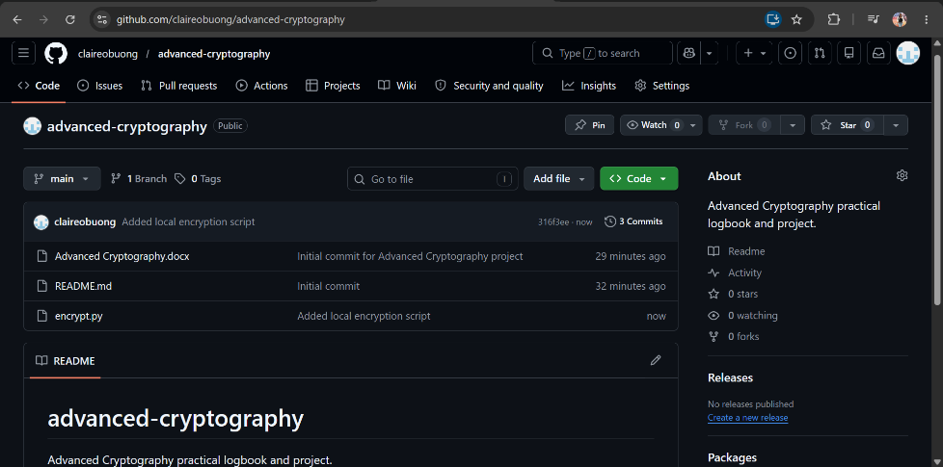
Figure 5: Illustrates initialization of the GitHub repository and version control setup, supporting secure code management and project tracking.

1.2 Reflection
Configuring the cryptography development environment improved my understanding of practical security tools. Testing encryption scripts and setting up OpenSSL and version control demonstrated the importance of secure development practices and proper tool configuration for cryptographic applications.

Week 2

2.1 Implementation of Classical Encryption Algorithms
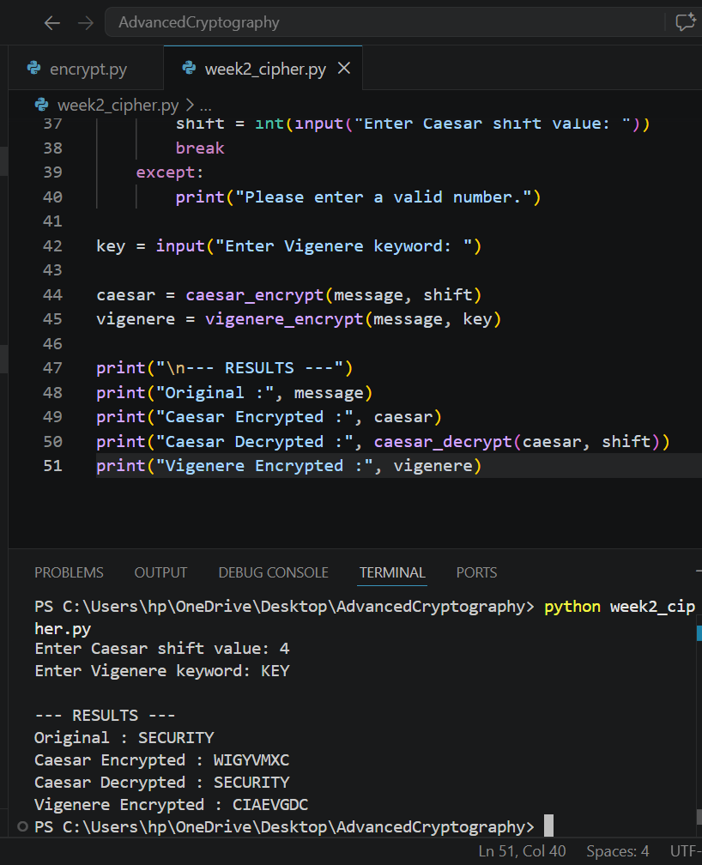
Figure 6: Demonstrates the implementation of the Caesar Cipher algorithm, where each character is shifted by a user-defined key to produce encrypted output.

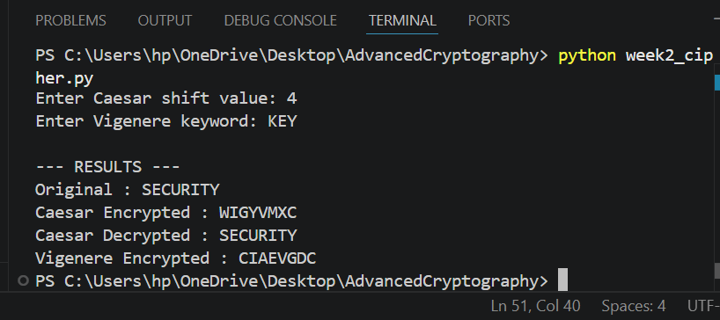
Figure 7: Illustrates the Vigenère Cipher encryption process, where a keyword is used to generate multiple substitution alphabets, improving security over simple shift ciphers.

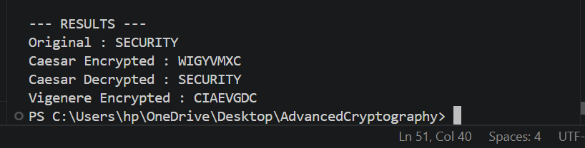
Figure 8: Confirms the successful encryption and decryption of plaintext, demonstrating that the original message can be accurately recovered using the correct key.
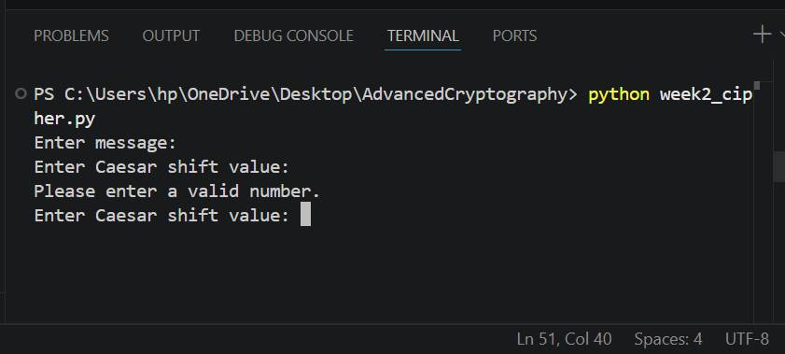
Figure 9: Demonstrates the user input interface, allowing dynamic entry of plaintext and encryption keys while validating numerical input for the Caesar Cipher.
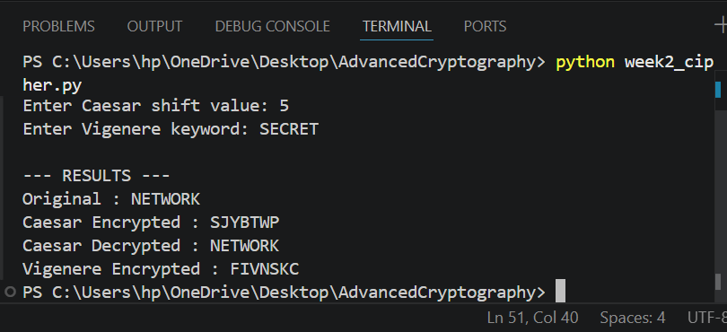
Figure 10: Presents the testing results obtained using different plaintext messages and encryption keys, verifying the correctness and consistency of the implemented algorithms.

2.2 Reflection
Implementing the Caesar and Vigenère ciphers improved my understanding of how encryption algorithms convert plaintext into ciphertext using secret keys. The practical exercises demonstrated the importance of key management, the encryption workflow and the security weaknesses of simple substitution techniques.

Week 3

3.1 Implementation of Stream Cipher Systems and Random Sequence Analysis

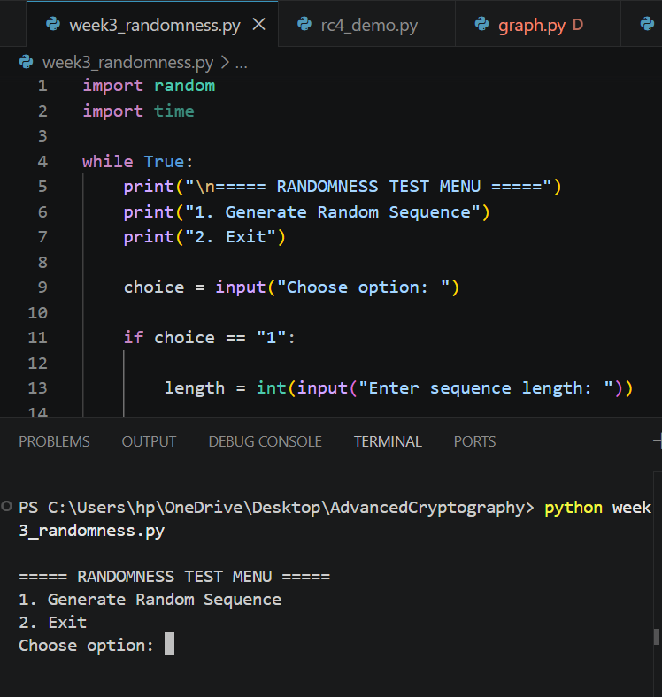
Figure 11: Implementation of a pseudorandom sequence generator for stream cipher security analysis.

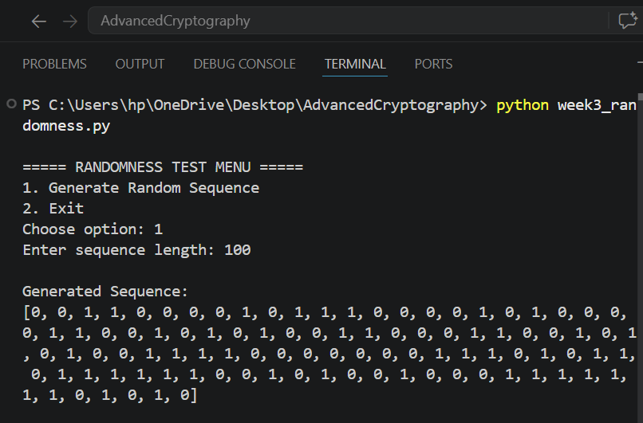
Figure 12: Generated pseudorandom binary sequence used for randomness analysis.

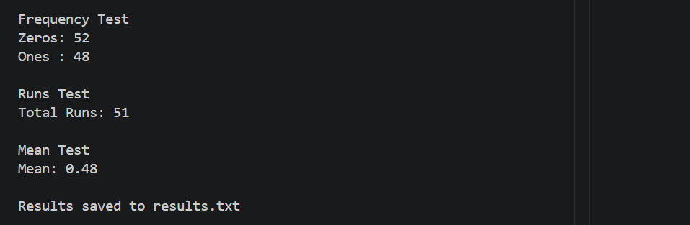
Figure 13: Statistical testing results showing frequency, runs, and mean analysis of the generated binary sequence.

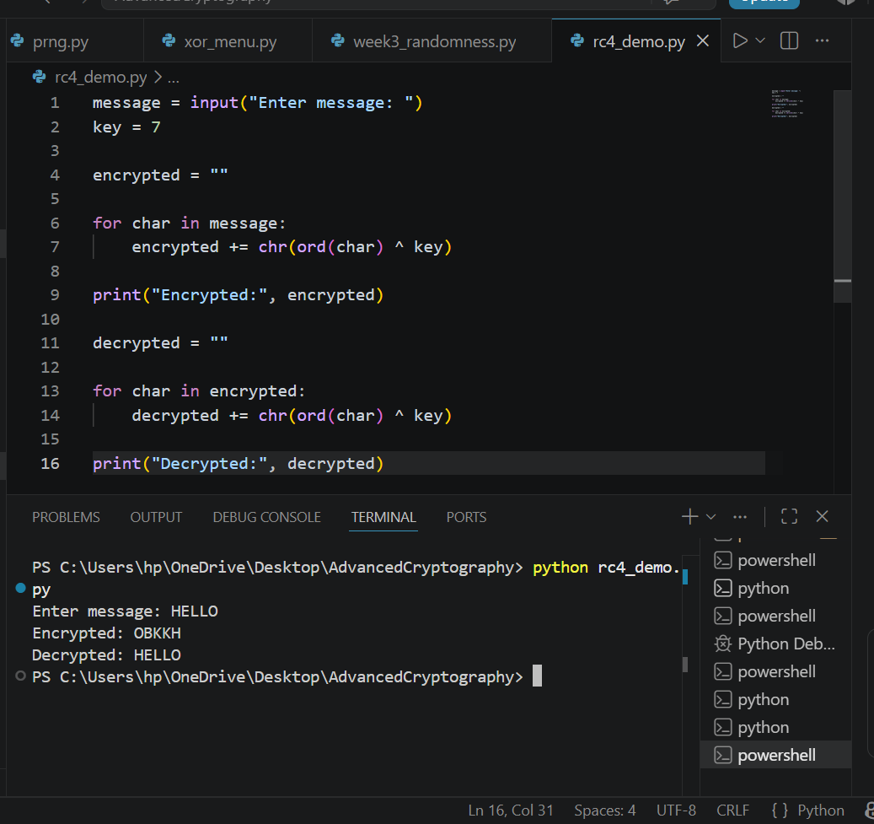
Figure 14: RC4-style stream cipher simulation demonstrating XOR-based encryption and decryption.
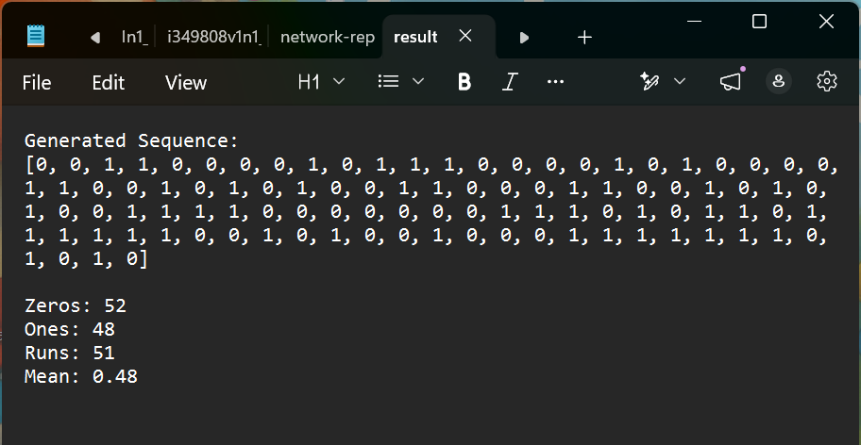
Figure 15: Encryption and randomness testing results successfully generated and stored for later analysis.

3.2 Reflection
Implementing pseudorandom sequence generation and stream cipher techniques improved my understanding of cryptographic security. Frequency, runs and mean tests were used to evaluate randomness quality, demonstrating the importance of strong pseudorandom generation for producing secure and unpredictable encryption.

Week 4

4.1 Advanced Encryption Standard (AES) and Block Cipher Operations
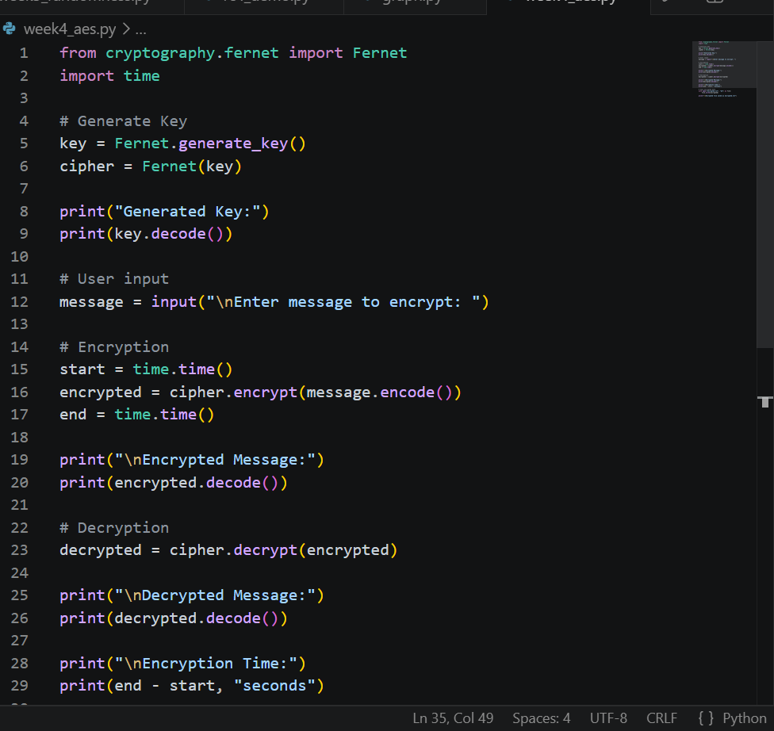
Figure 16: Python implementation of an AES-based encryption script using the Cryptography library.

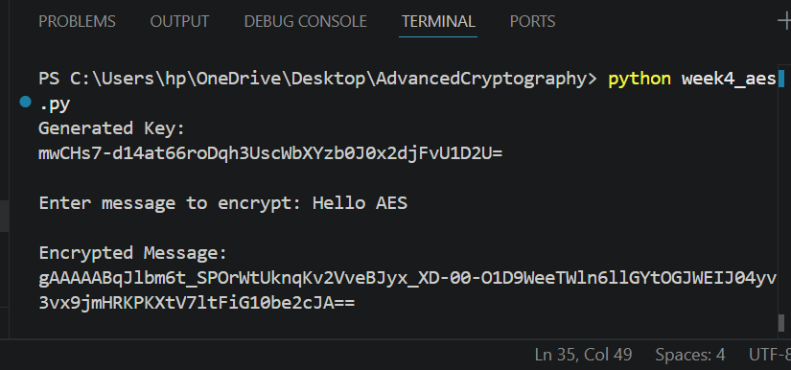
Figure 17: Automatic generation of a symmetric encryption key used for AES operations
.

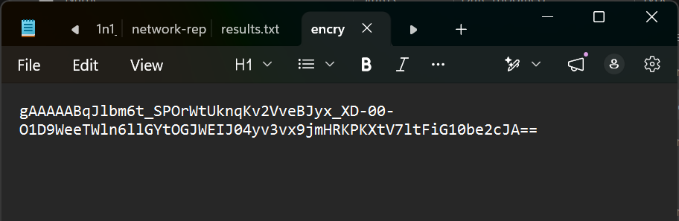
Figure 18: Encrypted output successfully stored in a file for secure data protection.
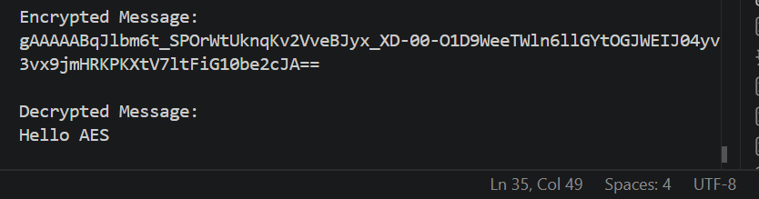
Figure 19: Successful decryption process demonstrating recovery of the original plaintext using the correct encryption key.

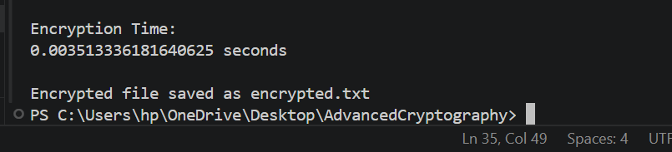
Figure 20: AES encryption performance measurement showing the execution time required for the encryption process.

4.2 Reflection
Working with AES encryption and decryption improved my understanding of the AES workflow and symmetric cryptography. The practical exercises demonstrated the importance of secure key management, the encryption and decryption process and the challenges involved in protecting data.

Week 5

5.1 Implementation of RSA Encryption and Key Management
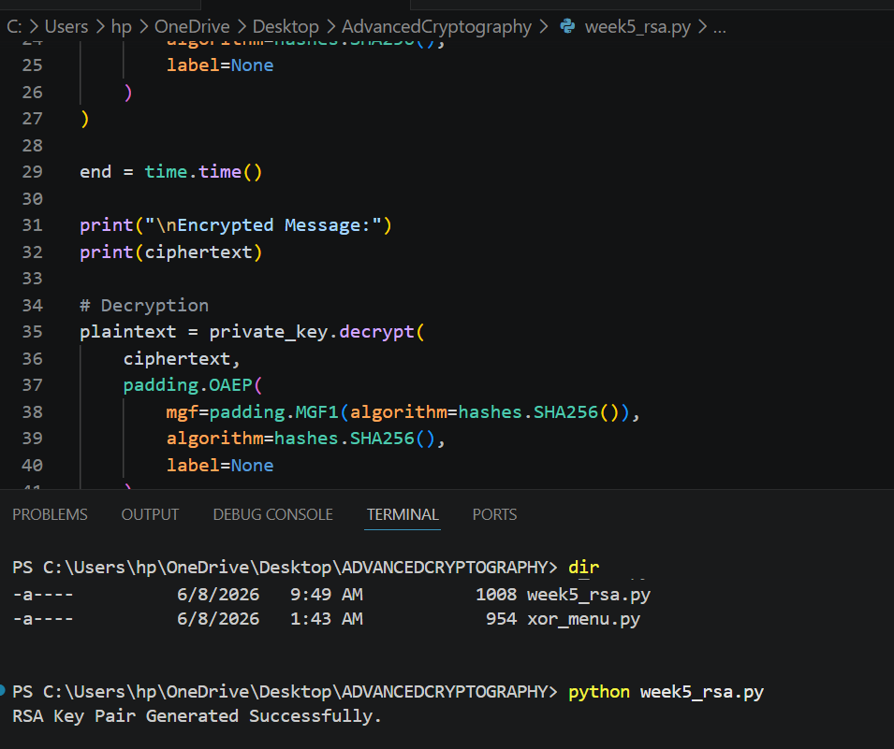
Figure 21: Successful generation of RSA public and private key pairs for secure communication.
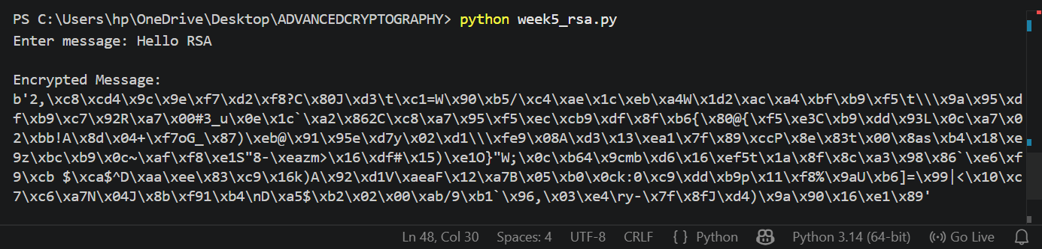
Figure 22: Encryption of plaintext using the RSA public key.

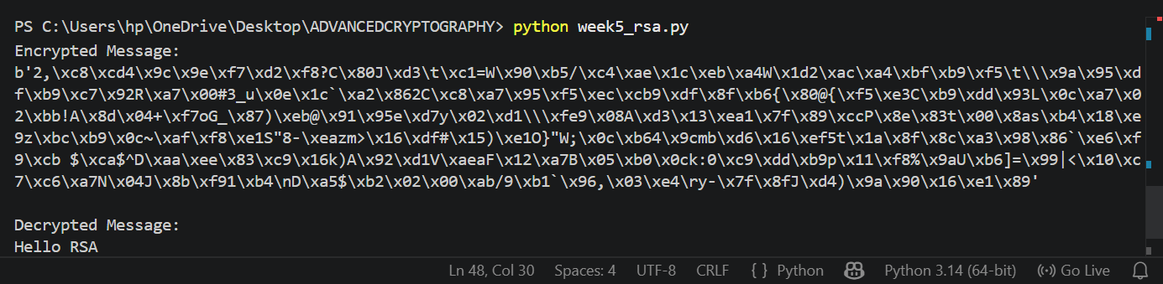
Figure 23: Successful decryption of ciphertext using the RSA private key.

Figure 24: RSA secure message transmission demonstrating protection of data during communication.

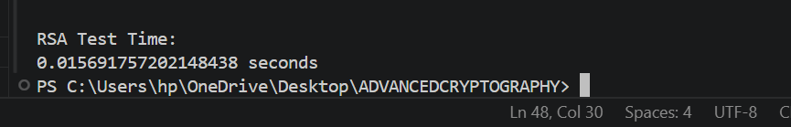
Figure 25: RSA encryption and decryption successfully tested and validated through execution time measurement.

5.2 Reflection
Developing the interactive cryptography toolkit improved my understanding of encryption, randomness testing, block ciphers and digital fingerprints. Integrating these concepts into one Python application demonstrated how different cryptographic techniques work together to enhance data security.

6. Creative task

6.1 Advanced Cryptography Toolkit: Interactive Encryption and Security Analysis System
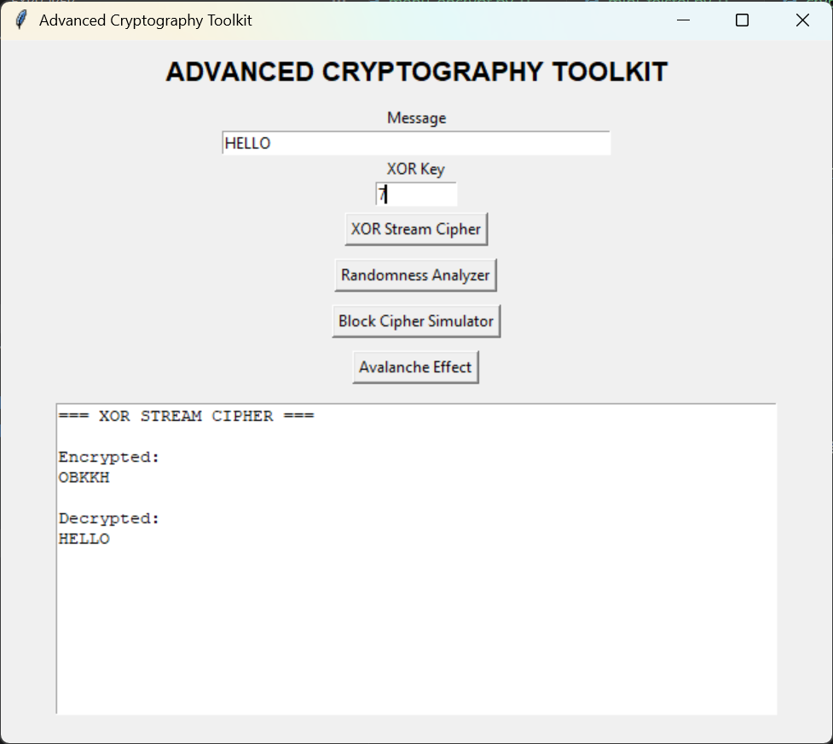
Figure 26: GUI-based XOR stream cipher demonstrating secure encryption and successful decryption using a shared key.
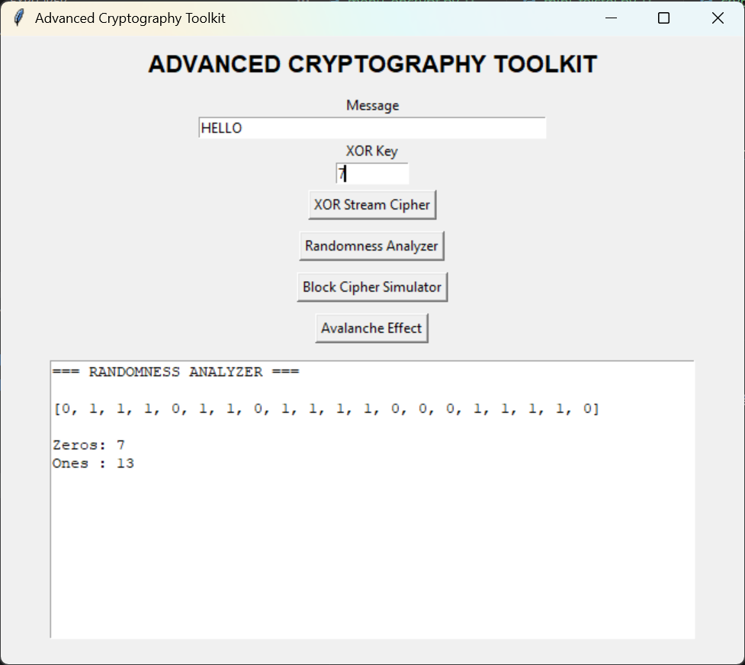
Figure 27: Randomness analyzer generating binary sequences and evaluating frequency distribution.
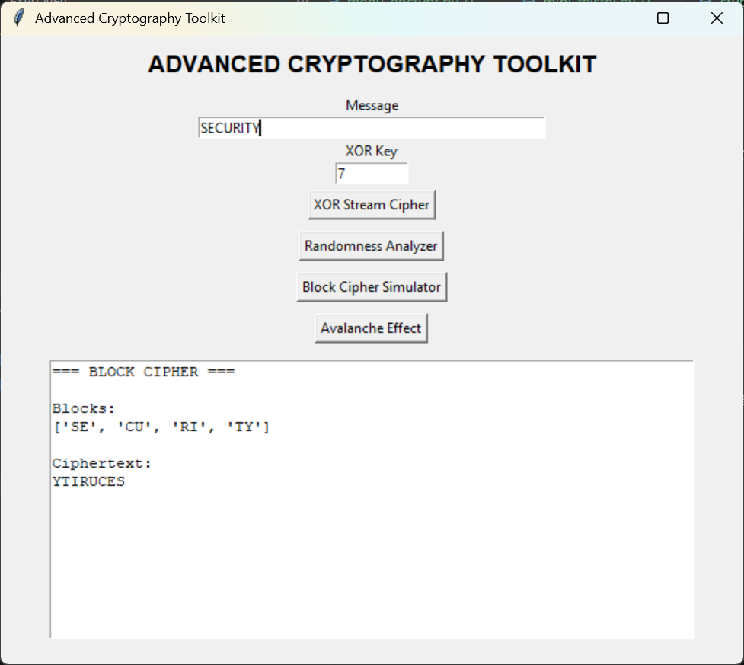
Figure 28: Block cipher simulator implementing block division, substitution, and permutation operations.
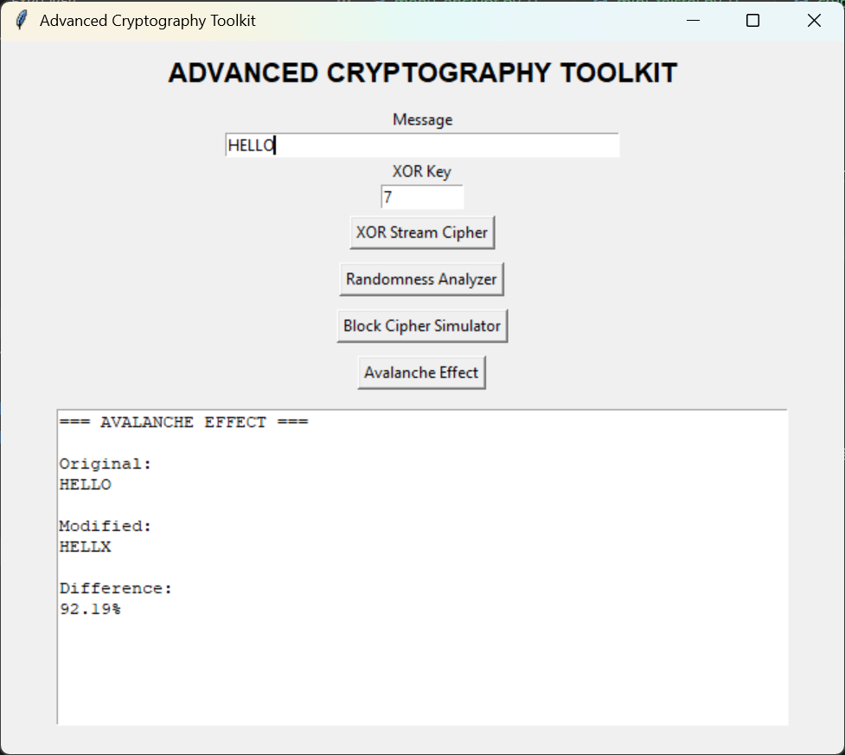
Figure 29: Avalanche effect demonstration showing how a small plaintext change produces significant cryptographic differences
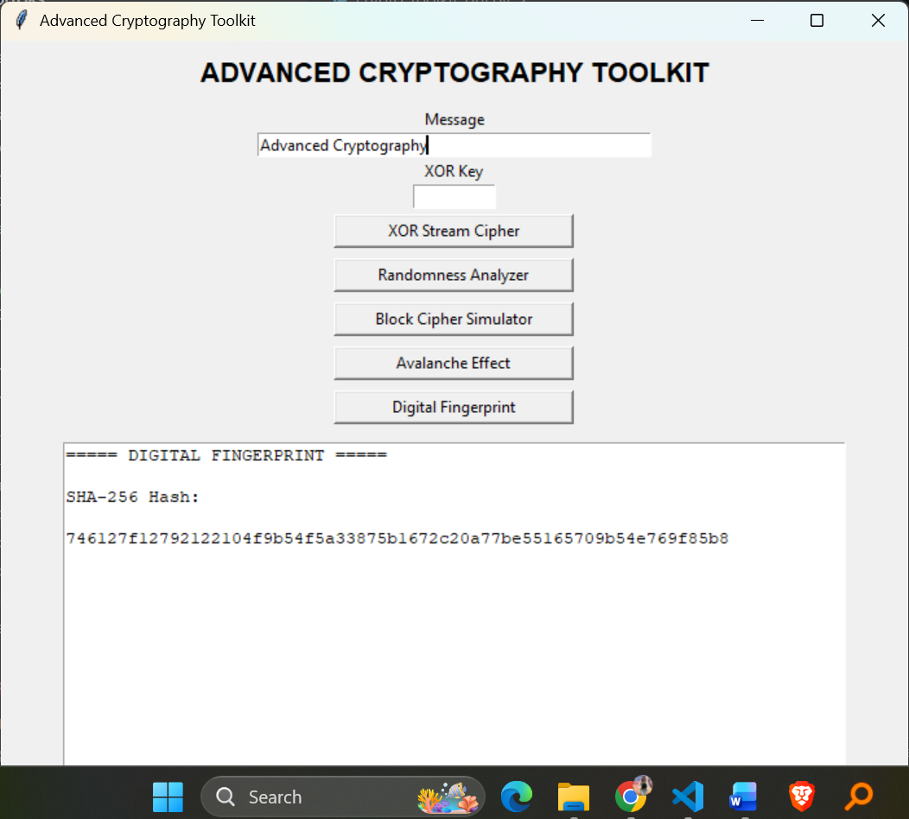
Figure 30: Digital fingerprint generator using SHA-256 hashing for message integrity verification.

6.2 Summary
I developed an interactive cryptography toolkit using Python and Tkinter to demonstrate XOR stream encryption, randomness analysis, block cipher simulation, avalanche effect testing and also the digital fingerprint generation. The project integrates multiple cryptographic concepts that I have learnt into a single user-friendly interface for practical security analysis.

